TECHNIQUES & TIPS FOR IELTS DISCUSSION ESSAY

Discussion Essays are probably the easiest to write of all IELTS essays so be glad if you get one in your test.

- Two Types of Discussion Essay
- There will be two sides of the same thing, such as homework is good for children / homework is bad for children.
- There will be two different options, such as the government should focus on building housing or on parks. These are two different things and you must address both.

- Instructions:
- Discuss both sides and give your opinion.
- Note: the discussion is not more important than the opinion. All parts of the instructions are important to fulfil.

- Identify both sides of the discussion in the essay question and prepare ideas (reasons why each side is valid)
- each side is about why other people support that side
- Choose your main ideas

- you don’t get a higher band score because you have more ideas.
- you get a higher band score because your ideas are relevant and well-developed.
- so, decide which ideas to use. You will usually have about two reasons to explain for each side of the discussion.
- Decide your opinion.

- Do you agree with one of the sides?
- Do you have your own balanced view which is a specific view that doesn’t fully agree and doesn’t fully disagree?
- You can’t change your opinion half way through your essay so make sure you have decided it before you start writing.
- Always write your introduction paragraph with two statements:

- Background statement = a paraphrase of the essay question. The biggest mistake is incorrect paraphrasing that changes the meaning of the essay question given.
- Thesis statement = presents your position clearly.
- Body Paragraphs

- Always have a topic sentence. This shows the examiner which side of the discussion you are about to tackle.
- Making the content and aim of your body paragraphs clear is essential to a high score.
- Topic sentences should help the essay flow clearly and help the examiner locate information easily.
- Not all body paragraphs require examples. If you can’t think of an example don’t worry. Just explain the main point as well as you can.
- Supporting points are basically points that explain the main idea. Imagine someone asking you again and again “What do you mean?” – “Explain yourself”. Good supporting points make the main idea clear.
- Don’t overcomplicate your ideas. Ideas should be clear and relevant, but language should have more complexity for a high score.
- Your opinion should also be restate in the body paragraphs.
- Conclusion

- Summarise all the main ideas you’ve given.
- This should be the shortest paragraph, usually one or two sentences.
- Never introduce a new main point in the conclusion.
- Always start the conclusion with the right linking word.

IELTS DISCUSSION ESSAY MODEL ANSWER

Discussion Essay Question

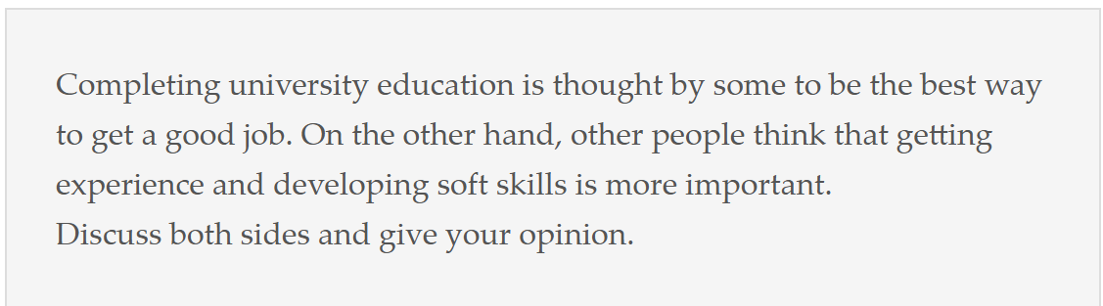

Discuss both sides and give your opinion.

Discussion Essay Model Answer

Please note that this essay is over 300 words. Longer doesn’t mean better. It is rare for an essay to go over 300 words or 310 words at most. Most IELTS essays are between 270 and 290 words, even for a band 9. However, 300 words, more or less, is possible as long as each sentence is highly focused and relevant. This Discussion Essay is an example of one such essay.

It is considered by some that being a university graduate is the key to securing a good job, while there are others who think that it is better to have experience and soft skills. In my opinion, I believe that having university education is essential for academic jobs, while soft skills and experience are more useful in business.

On the one hand, many people think finding a good job is easier if they have a graduate degree because having tertiary education puts people one step ahead of others. For many employers, this can be the deciding factor between job applicants. Furthermore, a certain level of university education is required for particular jobs, such as being a doctor or teacher. For this reason, I believe that in the case of jobs that require academic knowledge, having a tertiary education is the key to success.

On the other hand, having work experience and soft skills, such as leadership skills and other interpersonal skills, can also throw the balance in favour of the job applicant. For someone who is applying for management positions having experience of how to manage a team as well as strong interpersonal skills to support and direct staff, experience and soft skills are critical. Business is also an area of work where experience puts a person ahead of the competition in a way that university education could not. For this reason I also believe that such skills do have a relevant place in the workplace.

In conclusion, getting a good job requires a relevant background either in experience or education depending on the type of work and field. Some positions require an academic background, whilst others benefit more from experience and skills. （283 words）

